Determining the age of worker honey bees (Apis mellifera L.) that ingest pollen substitute patties

Emily R. Noordyke, Kaylin Kleckner, Cody Prouty, Jamie D. Ellis

Hypotheses
We investigated at what age worker honey bees (Apis mellifera) ingest pollen substitute patties (PSPs) by exposing cohorts of workers to dyed PSPs and evaluating the presence of the dye in their abdomen. We hypothesized that nurse bees (workers aged 5-10 days) would be the main consumers of the PSPs and have the most dye present in their abdomen given the high demand for pollen by the maturing larvae they care for (Crailsheim 1990). Alternatively, we hypothesized that PSPs would not be treated the same as bee-collected pollen stored in cells as bee bread. Therefore, foraging workers (aged 18-28 days) would be the main consumers of the PSP for their high sugar content and have the highest proportional presence of dye in their abdomen.

Methodology
Experimental design
To investigate at what age worker honey bees consume PSPs, we looked for the presence of dyed PSPs in the abdomens of worker bees each day of their lifespan. Pollen traps were placed on the entrances of fifteen colonies in five-frame Langstroth equipment to exclude local pollen foraging. The treatment groups were as follows: (1) six colonies received a dyed commercial pollen substitute, (2) three colonies received commercial pollen substitute without dye (negative control), (3) three colonies received fondant mixed with dye (positive control), and (4) three colonies received Crayola model magic clay mixed with dye (consumption control). Honey bees will not eat Crayola Model Magic clay and in some cases eject it from the hive (Noordyke et al. 2021). The negative and consumption controls were 100% effective with no dye present and the positive was 97.7% effective. Diets were fed ad libitum for 28 days and colonies were spaced 20 meters apart to reduce the chance of individuals drifting from one colony to another.

We gathered newly emerged bees < 24 h old over three consecutive days in October 2020. All newly emerged bees were placed in a single container and allowed to mix thoroughly to reduce the potential effects of genetic variation between colonies. We painted the thoraces of the newly emerged bees using Testors Enamel paint (The Testor Corporation, Rockford, IL). Groups of eight hundred painted bees were introduced to five randomly selected colonies the same day that they were painted. We heavily smoked colonies, closed colony entrances, and lightly misted the introduced bees with a sucrose solution to prevent ejection. We added appropriate diets in petri dishes (11 cm diameter, 1 cm deep) on the top bars and opened colony entrances approximately two hours after introducing the painted bees. Data collection began one day after painting, when workers were approximately two days old.

Data collection
We systematically collected 20 painted bees from each colony every day for 28 days (approximately 560 total marked workers collected per hive). We collected two painted bees per side of each of five frames. Many colonies had fewer than two painted bees per side of each frame during the last week of the study. In this case, we collected more than two painted bees on the next nearest frame until we had a full sample. Some days near the end of the study, we would not find 20 painted bees in a colony and would collect as many as we could find to get a partial sample. If we could not find any painted bees in a colony for two days in a row, then we took the colony out of the study. Bee samples were stored in the freezer at -6°C until dye extraction. We extracted dye from worker bee abdomens using methods from Noordyke et al. (2021). Two observers visually inspected samples for the presence of dye by holding vials over a white surface under the same lighting conditions. Only samples in which the two visual graders agreed were included in our statistical analysis.

We utilized weather data from the University of Florida IFAS Florida Automated Weather Network (FAWN) to account for potential environmental covariates impacting PSP consumption. We accessed hourly measurements of numerous metrics taken at the Alachua 260 station (29.80266, -82.41081;15 miles from UF HBREL) for October of 2020. For presence of dye in bee guts, we summarized the average value of each metric for the 23 hours preceding sampling (12:00 – 11:00). For the number of bees observed on patties, we summarized the average value of each metric for the period of sunrise to average observation time (7:00 – 11:00). Additionally, we visualized the correlation between environmental metrics using a correlation matrix and corrplot::corrplot in R (version 1.4.3) to avoid selecting highly correlated metrics in our models.

Data analysis
General analyses
To test our hypothesis that nurse bees (5-10 days old) would drive PSP consumption, we constructed generalized linear mixed effects models in R (version 1.4.3). Our full models included worker age as linear and quadratic fixed effect predictor variables. We included the quadratic term based on our prediction that response variables would peak at days five to ten. Additionally, we selected the average of four biologically relevant environmental metrics (Clarke and Robert 2018; Wang et al. 2009) to include as fixed effect covariates in our full model: temperature measured 60 cm above the ground, rainfall, radiation, and humidity. For comparisons, we scaled all environmental covariates to have a mean of zero and a one-unit increase represent an increase of one standard deviation. To account for time-dependent hive effects, we adopted a hive random effect with a first-order autoregressive (AR1) correlation structure. An AR1 correlation structure accounts for higher correlation in time points closer together (Shan et al. 2020). From the full model, we created subsequent models with all possible combinations of environmental covariates (Symonds and Moussalli 2011) and a variety of null models with (1) a hive random effect without AR1 correlation structure, (2) only weather variables, (3) no quadratic age fixed effect predictor variable, and (4) no predictor variables (response ~ 1). All models were constructed with glmmTMB::glmmTMB (Brooks et al. 2017).
We utilized Akaike’s Information Criterion (AICc) (Akaike 1998; Grueber et al. 2011; Symonds and Moussalli 2011) to perform model selection and evaluate our candidate models. This exploratory method is an alternative to traditional null-hypothesis significance testing and thus does not generate p-values (Grueber et al. 2011; Symonds and Moussalli 2011; Tredennick et al. 2021). We calculated AICc scores, change in AICc scores (∆_{i}=AICc_{i} − minimum AICc), and AICc weight with MuMIn::model.sel (Bartoń 2022). We considered models with smaller AICc values and fewer predictor variables to be more parsimonious (Burnham and Anderson 2004). We averaged our top models using MuMIn::model_avg (Bartoń 2022) and then selected the conditional average, or natural average, to avoid estimate shrinkage and investigate minor effects of environmental variables on our system (Grueber et al. 2011). We examined estimate sizes from the averaged model to identify the important variables for our system and select the most parsimonious model for the rest of the analysis. With the most parsimonious model, Estimated Marginal Means (EMMs) and 95% confidence intervals of the response variables were calculated across worker age using emmeans::emmeans (Lenth 2022). We visually assessed various model assumptions for our most parsimonious model using simulated residuals in DHARMa:: simulateResiduals (Hartig 2022).
We further evaluated the effect of the selected environmental variables on our response variables across worker age through visual assessment of each environmental variable plotted against the residuals from a generalized linear mixed effects model with every environmental variable that was not plotted. This model retained its respective distribution, age as linear and quadratic fixed effect predictor variables, offset for background mortality (in observations of bees on PSPs), and a hive random effect with a first-order autoregressive (AR1) correlation structure. We fit a generalized linear model and examined the direction and steepness of the slope, representing the relationship between each environmental variable and our system. Slopes nearly or equal to zero indicated a minimal, if any, effect of the environmental variable. We elected to assess each environmental variable against the residuals of our selected models instead of raw means of each response variable to account for the various terms and random effects in our models, similar to how the averaged model estimates were calculated.

Presence of dye in bees’ guts
To test effects on presence of dye in bees’ guts, we selected models with a binomial distribution (1 = dye present, 0 = dye absent) and dye presence as the response variable. We initially examined all models within ∆i < 6 (Richards 2005). However, fifteen of our twenty models were within ∆i < 6 and our goal of model selection was not met. Thus, we applied a more restrictive criteria of ∆i < 2 to consider and average our top models for this response variable (Symonds and Moussalli 2011).

Observations of marked bees on PSPs
To test effects on observations of marked bees on PSPs, we selected models with a negative binomial or Poisson distribution (Table x). In this response variables, treatment groups for both AP23 dyed and undyed (negative control) were combined, as we hypothesized that the presence of dye would not affect the number of marked bees contacting PSPs. To account for the removal of marked bees and background mortality, an offset fixed effect was employed as the log (total number of bees in each colony). The total number of bees in each colony was calculated using the following formula: [number of bees at the start of the day (800 for day 1) – number of bees removed (usually 20 bees per day) – background mortality of the number of bees left after removal each day]. The background mortality was calculated as the median rate of 3.7% (ESFA, 2020), unless total bee counts were reduced below zero, in which case we reduced the background mortality rate by 0.1% until total bees were above zero at the end of the sampling period. For this response variable, we used an additional null model with the offset fixed effect removed for model selection.

∆

Results
Presence of dye in bees’ guts
Of our twenty constructed models, fifteen were within $∆$_{i} < 6 (AICc = 3343.0 – 3349.0, Table 1) and three were within $∆$_{i} < 2 (AICc = 3343.0 – 3344.9, Table 1). All top models included the hive random effect with AR1 correlation structure (Table 1). The averaged model revealed worker age as both a linear (estimate ± SE = 0.365 ± 0.055) and quadratic term (-0.009 ± 0.002) were important in our system. Temperature (scaled estimate ± SE = 0.213 ± 0.086; Figure 3A) and humidity (-0.248 ± 0.099; Figure 3D) had a weak effect on our system, while rainfall (0.065 ± 0.054; Figure 3B) and radiation (-0.039 ± 0.107; Figure 3C) had nearly no effect. We selected model 1, including temperature and humidity, as our final model because it was the most parsimonious while including all essential predictor variables (Table 1).

In our final model, as worker age increased, the proportion of dye presence from PSP consumption gradually increased until peaking at days 19 (EMM= 0.640, 95% CI = 0.548 - 0.723) and 20 (EMM= 0.640, 95% CI = 0.549 - 0.722; Figure 1, Table 3). After day 20, the proportion of dye presence gradually decreased until the end of sampling at 29 days old (Figure 1, Table 3). When examining the proportion of dye presence across worker age for each of the six colonies, we found variation in the amount of dyed PSP consumed and the shape of the trend over time (VC=0.302; Figure 1). In our final model, temporal autocorrelation was strong (AR1 correlation coefficient = 0.90). All model assumptions were satisfied through visual inspection of the simulated residuals.

Observations of marked bees on PSPs
The averaged model revealed worker age as both a linear (estimate ± SE = 0.487 ± 0.064) and quadratic term (-0.013 ± 0.002) were important in our system. Temperature (scaled estimate ± SE = 0.411 ± 0.12; Figure 4A) and rainfall (0.324 ± 0.108; Figure 4B) influenced our system, while radiation (0.288 ± 0.131; Figure 4C) and humidity (0.188 ± 0.139; Figure 4D) had weaker effects. We selected model 1 as our final model because it was the most parsimonious while including all essential predictor variables (Table 2).

In our final model, as worker age increased, the number of marked bees observed on PSP gradually increased until peaking at day 19 (EMM= 3.73, 95% CI = 2.69 – 5.17). After day 19, the proportion of dye presence gradually decreased until the end of sampling at 29 days old (Figure 2, Table 4). When examining the number of marked bees observed on PSPs across worker age for each of the nine colonies, we found variation in the amount of dyed PSP consumed and the shape of the trend over time (VC=0.282; Figure 2). In our final model, temporal autocorrelation was strong (AR1 correlation coefficient = 0.88). All model assumptions were satisfied through visual inspection of the simulated residuals.

Mini discussion
Our study investigated at what age do adult worker honey bees consume PSPs. While artificial pollen supplements are widely used by beekeepers, little is known regarding their consumption or effectiveness. To understand how effective PSPs are, we first must investigate whether they are consumed at all. We hypothesized that workers aged 5-10 days acting as nurse bees would consume the most PSPs due to the demand of pollen from growing honey bee larvae. Alternatively, we hypothesized workers aged 18-28 days serving as foragers would consume the most PSPs for energy.

From our experiment, our alternative hypothesis was supported. PSP consumption gradually increased throughout days 5-10 but peaked at day 20 – well after workers are serving as nurse bees. The pattern of PSP consumption varied from hive-to-hive, with one hive demonstrating a linear trend of PSP consumption increasing steadily throughout worker age. Although temperature and humidity were incorporated in our final model based on averaged model estimates, visual assessments revealed these variables had a weak effect on our system overall. Rainfall and radiation demonstrated a very minimal, if any, effect on PSP consumption patterns in our system. Across seasons or a longer experimental period patterns of environmental covariates and PSP consumption may emerge. Hive variation and the lack of environmental covariate influence suggests PSP consumption is dependent on internal colony needs, such as existing resources, cohorts of workers, and amount of developing brood. We suggest the absence of peak PSP consumption at the age of nursing workers means PSPs are not treated like bee-collected pollen. Therefore, using PSPs to supplement colony protein requirements may be futile. Future research is needed to investigate other forms of pollen supplementation to assist beekeepers in treating colony nutrient deficiencies.

References
Akaike, H. 1998. Information Theory and an Extension of the Maximum Likelihood Principle, pp. 199–213. In Parzen, E., Tanabe, K., Kitagawa, G. (eds.), Selected Papers of Hirotugu Akaike, Springer Series in Statistics. Springer New York, New York, NY.
Bartoń, K. 2022. MuMIn: Multi-Model Inference. R package version 1.46.0. https://CRAN.R-project.org/package=MuMIn
Brooks, M. E., K. Kristensen, K. J. van Benthem, A. Magnusson, C. W. Berg, A. Nielsen, H. J. Skaug, M. Maechler and B. M. Bolker. 2017. glmmTMB Balances Speed and Flexibility Among Packages for Zero-inflated Generalized Linear Mixed Modeling. The R Journal, 9(2), 378-400.
Burnham, K. P., and D. R. Anderson. 2004. Multimodel Inference: Understanding AIC and BIC in Model Selection. Sociological Methods & Research. 33: 261–304.
Clarke, D., and D. Robert. 2018. Predictive modelling of honey bee foraging activity using local weather conditions. Apidologie. 49: 386–396.
Crailsheim, K. 1990. The protein balance of the honey bee worker. Apidologie. 21: 417–429.
European Food Safety Authority (EFSA), Ippolito, A., Aguila, M. D., Aiassa, E., Guajardo, I. M., Neri, F. M., ... & Szentes, C. 2020. Review of the evidence on bee background mortality (Vol. 17, No. 7, p. 1880E).

Hartig, F. 2022. DHARMa: Residual Diagnostics for Hierarchical (Multi-Level/Mixed) Regression Models. R package version 0.4.5. https://CRAN.R-project.org/package=DHARMa

Grueber, C. E., S. Nakagawa, R. J. Laws, and I. G. Jamieson. 2011. Multimodel inference in ecology and evolution: challenges and solutions. Journal of Evolutionary Biology. 24: 699–711.
Lenth, R. V. 2022. emmeans: Estimated Marginal Means, aka Least-Squares Means. R package version 1.7.2. https://CRAN.R-project.org/package=emmeans
Noordyke, E. R., E. v. Santen, J. D. Ellis. 2021. Tracing the Fate of Pollen Substitute Patties in Western Honey Bee (Hymenoptera: Apidae) Colonies. Journal of Economic Entomology. 114:4. 1421–1430,
Richards, S. A. 2005. Testing ecological theory using the information-theoretic approach: examples and cautionary results. 86: 10.
Shan, G., H. Zhang, and T. Jiang. 2020. Correlation Coefficients for a Study with Repeated Measures. Comput Math Methods Med. 2020: 7398324.
Symonds, M. R. E., and A. Moussalli. 2011. A brief guide to model selection, multimodel inference and model averaging in behavioural ecology using Akaike’s information criterion. Behav Ecol Sociobiol. 65: 13–21.
Tredennick, A. T., G. Hooker, S. P. Ellner, and P. B. Adler. 2021. A practical guide to selecting models for exploration, inference, and prediction in ecology. Ecology. 102: e03336.
Wang, X., H. Liu, X. Li, Y. Song, L. Chen, and L. Jin. 2009. Correlations Between Environmental Factors and Wild Bee Behavior on Alfalfa (Medicago sativa) in Northwestern China. Environmental Entomology. 38: 1480–1484.

Figures and tables
Table 1. Evaluation of twenty candidate models for dye presence in workers with variable fixed effect predictor variables and random effect structure via corrected Akaike’s Information Criterion (AICc).
 | Candidate Models | Random effect | df | AICc | $∆$_{i} | AICc weight
1 | A+A² +T+H | A | H | 7 | 3343.0 | 0.00 | 0.279
2 | A+A² +T+RF+H | A | H | 8 | 3343.5 | 0.55 | 0.212
3 | A+A² +T+R+H | A | H | 8 | 3344.9 | 1.88 | 0.109
4 | A+A² +T+RF+R+H | A | H | 9 | 3345.6 | 2.56 | 0.078
5 | A+A² | A | H | 5 | 3346.2 | 3.23 | 0.056
6 | A+A² +H | A | H | 6 | 3346.5 | 3.54 | 0.047
7 | A+A² +RF+H | A | H | 7 | 3347.2 | 4.21 | 0.034
8 | A+A² +T | A | H | 6 | 3347.2 | 4.25 | 0.033
9 | A+A² +RF | A | H | 6 | 3347.7 | 4.74 | 0.026
10 | A+A² +R+H | A | H | 7 | 3347.8 | 4.80 | 0.025
11 | A+A² +T+R | A | H | 7 | 3348.0 | 4.98 | 0.023
12 | A+A² +R | A | H | 6 | 3348.1 | 5.12 | 0.022
13 | A+A² +RF+R+H | A | H | 8 | 3348.9 | 5.88 | 0.015
14 | A+A² +T+RF+R | A | H | 8 | 3348.9 | 5.95 | 0.014
15 | A+A² +T+RF | A | H | 7 | 3349.0 | 5.98 | 0.014
16 | A+A² +RF+R | A | H | 7 | 3349.3 | 6.30 | 0.012
17 | A | A | H | 4 | 3372.2 | 29.16 | 0.000
18 | T+RF+R+H | A | H | 7 | 3384.9 | 41.93 | 0.000
19 | A | 1 | H | 3 | 3431.1 | 88.07 | 0.000
20 | 1 | NA | 1 | 3730.4 | 387.40 | 0.000

Predictor variables: A=Linear age term, A²=Quadratic age term, T=Average daily temperature, RF=Average daily rainfall, R=Average daily radiation, H=Average daily humidity, 1=Null model
Random effect structure: A | H = Hive random effect with first-order autoregressive (AR1) correlation structure, 1 | H = Hive random effect, NA = not applicable
$∆$_{i} : AICc_{i} − minimum AICc

Table 2. Evaluation of candidate models for marked bees observed on PSPs with variable fixed effect predictor variables and random effect structure via corrected Akaike’s Information Criterion (AICc).
 | Candidate Model | Random effect | df | AICc | ∆_{i} | AICc weight | Family
1 | A+A² +off(TB)+T+R+Rd+H | A | H | 10 | 695.2 | 0.00 | 0.426 | nbinom2(log)
2 | A+A² +off(TB)+T+R+Rd | A | H | 9 | 695.5 | 0.29 | 0.368 | nbinom2(log)
3 | A+A² +off(TB)+T+R | A | H | 8 | 697.7 | 2.53 | 0.120 | nbinom2(log)
4 | A+A² +off(TB)+T+R+H | A | H | 9 | 699.8 | 4.64 | 0.042 | nbinom2(log)
5 | A+A² +off(TB)+T+Rd+H | A | H | 8 | 702.2 | 7.00 | 0.013 | poisson(log)
6 | A+A² +off(TB)+R+Rd+H | A | H | 8 | 702.6 | 7.38 | 0.011 | poisson(log)
7 | A+A² +off(TB)+T+H | A | H | 8 | 703.3 | 8.12 | 0.007 | nbinom2(log)
8 | A+A² +off(TB)+T | A | H | 7 | 703.6 | 8.41 | 0.006 | nbinom2(log)
9 | A+A² +off(TB)+T+ Rd | A | H | 8 | 705.7 | 10.46 | 0.002 | nbinom2(log)
10 | A+A² +off(TB)+R+H | A | H | 8 | 705.8 | 10.63 | 0.002 | nbinom2(log)
11 | A+A² +off(TB)+H | A | H | 7 | 706.6 | 11.43 | 0.001 | nbinom2(log)
12 | A+A² +off(TB)+Rd+H | A | H | 8 | 708.2 | 12.98 | 0.001 | nbinom2(log)
13 | A+A² +off(TB)+R | A | H | 7 | 712.2 | 16.94 | 0.000 | nbinom2(log)
14 | A+A² +off(TB)+R+Rd | A | H | 8 | 713.4 | 18.22 | 0.000 | nbinom2(log)
15 | A+A² +off(TB)+Rd | A | H | 7 | 715.3 | 20.05 | 0.000 | nbinom2(log)
16 | A+A² | A | H | 6 | 717.5 | 22.30 | 0.000 | nbinom2(log)
17 | A+A² +off(TB) | A | H | 6 | 720.7 | 25.45 | 0.000 | nbinom2(log)
18 | A | A | H | 4 | 774.1 | 78.92 | 0.000 | poisson(log)
19 | A | NA | 3 | 816.9 | 121.67 | 0.000 | nbinom2(log)
20 | 1 | NA | 2 | 819.2 | 123.96 | 0.000 | nbinom2(log)
21 | off(TB)+T+R+Rd+H | A | H | 8 | 953.4 | 258.24 | 0.000 | gaussian(identity)
Predictor variables: A=Linear age term, A²=Quadratic age term, off(TB) = offset variable of log transformed total number of bees, T=Average daily temperature, RF=Average daily rainfall, R=Average daily radiation, H=Average daily humidity, 1=Null model
Random effect structure: A | H = Hive random effect with first-order autoregressive (AR1) correlation structure, 1 | H = Hive random effect, NA = not applicable
∆_{i} : AICc_{i} − minimum AICc

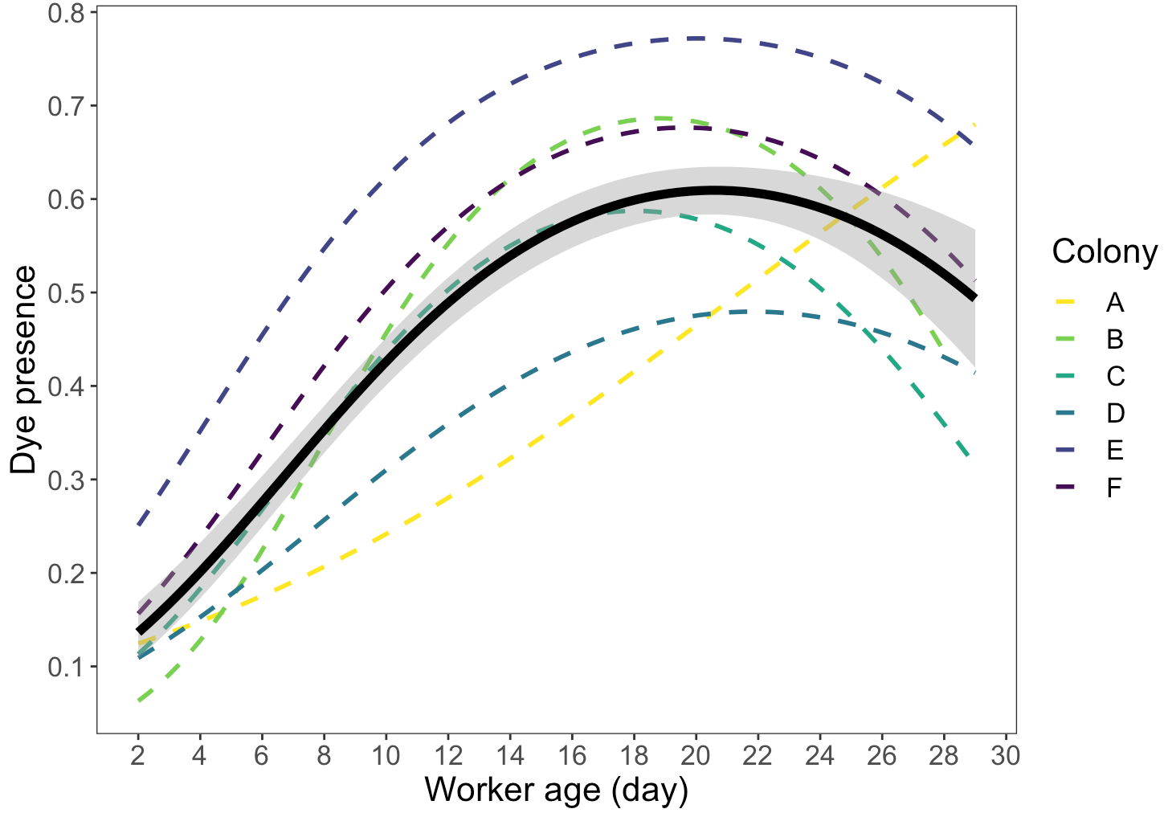
Figure 1. Proportion of dye presence from pollen substitute patty consumption as worker age increases. The continuous black line with gray shading represents the estimated curve and 95% confidence interval from a generalized linear model with a binomial distribution of all colonies. Estimated curves for each of the six colonies are represented by the multicolor dashed lines. On average, dye presence peaks at 19-20 days of age. The proportion and timing of dye presence varies by colony.

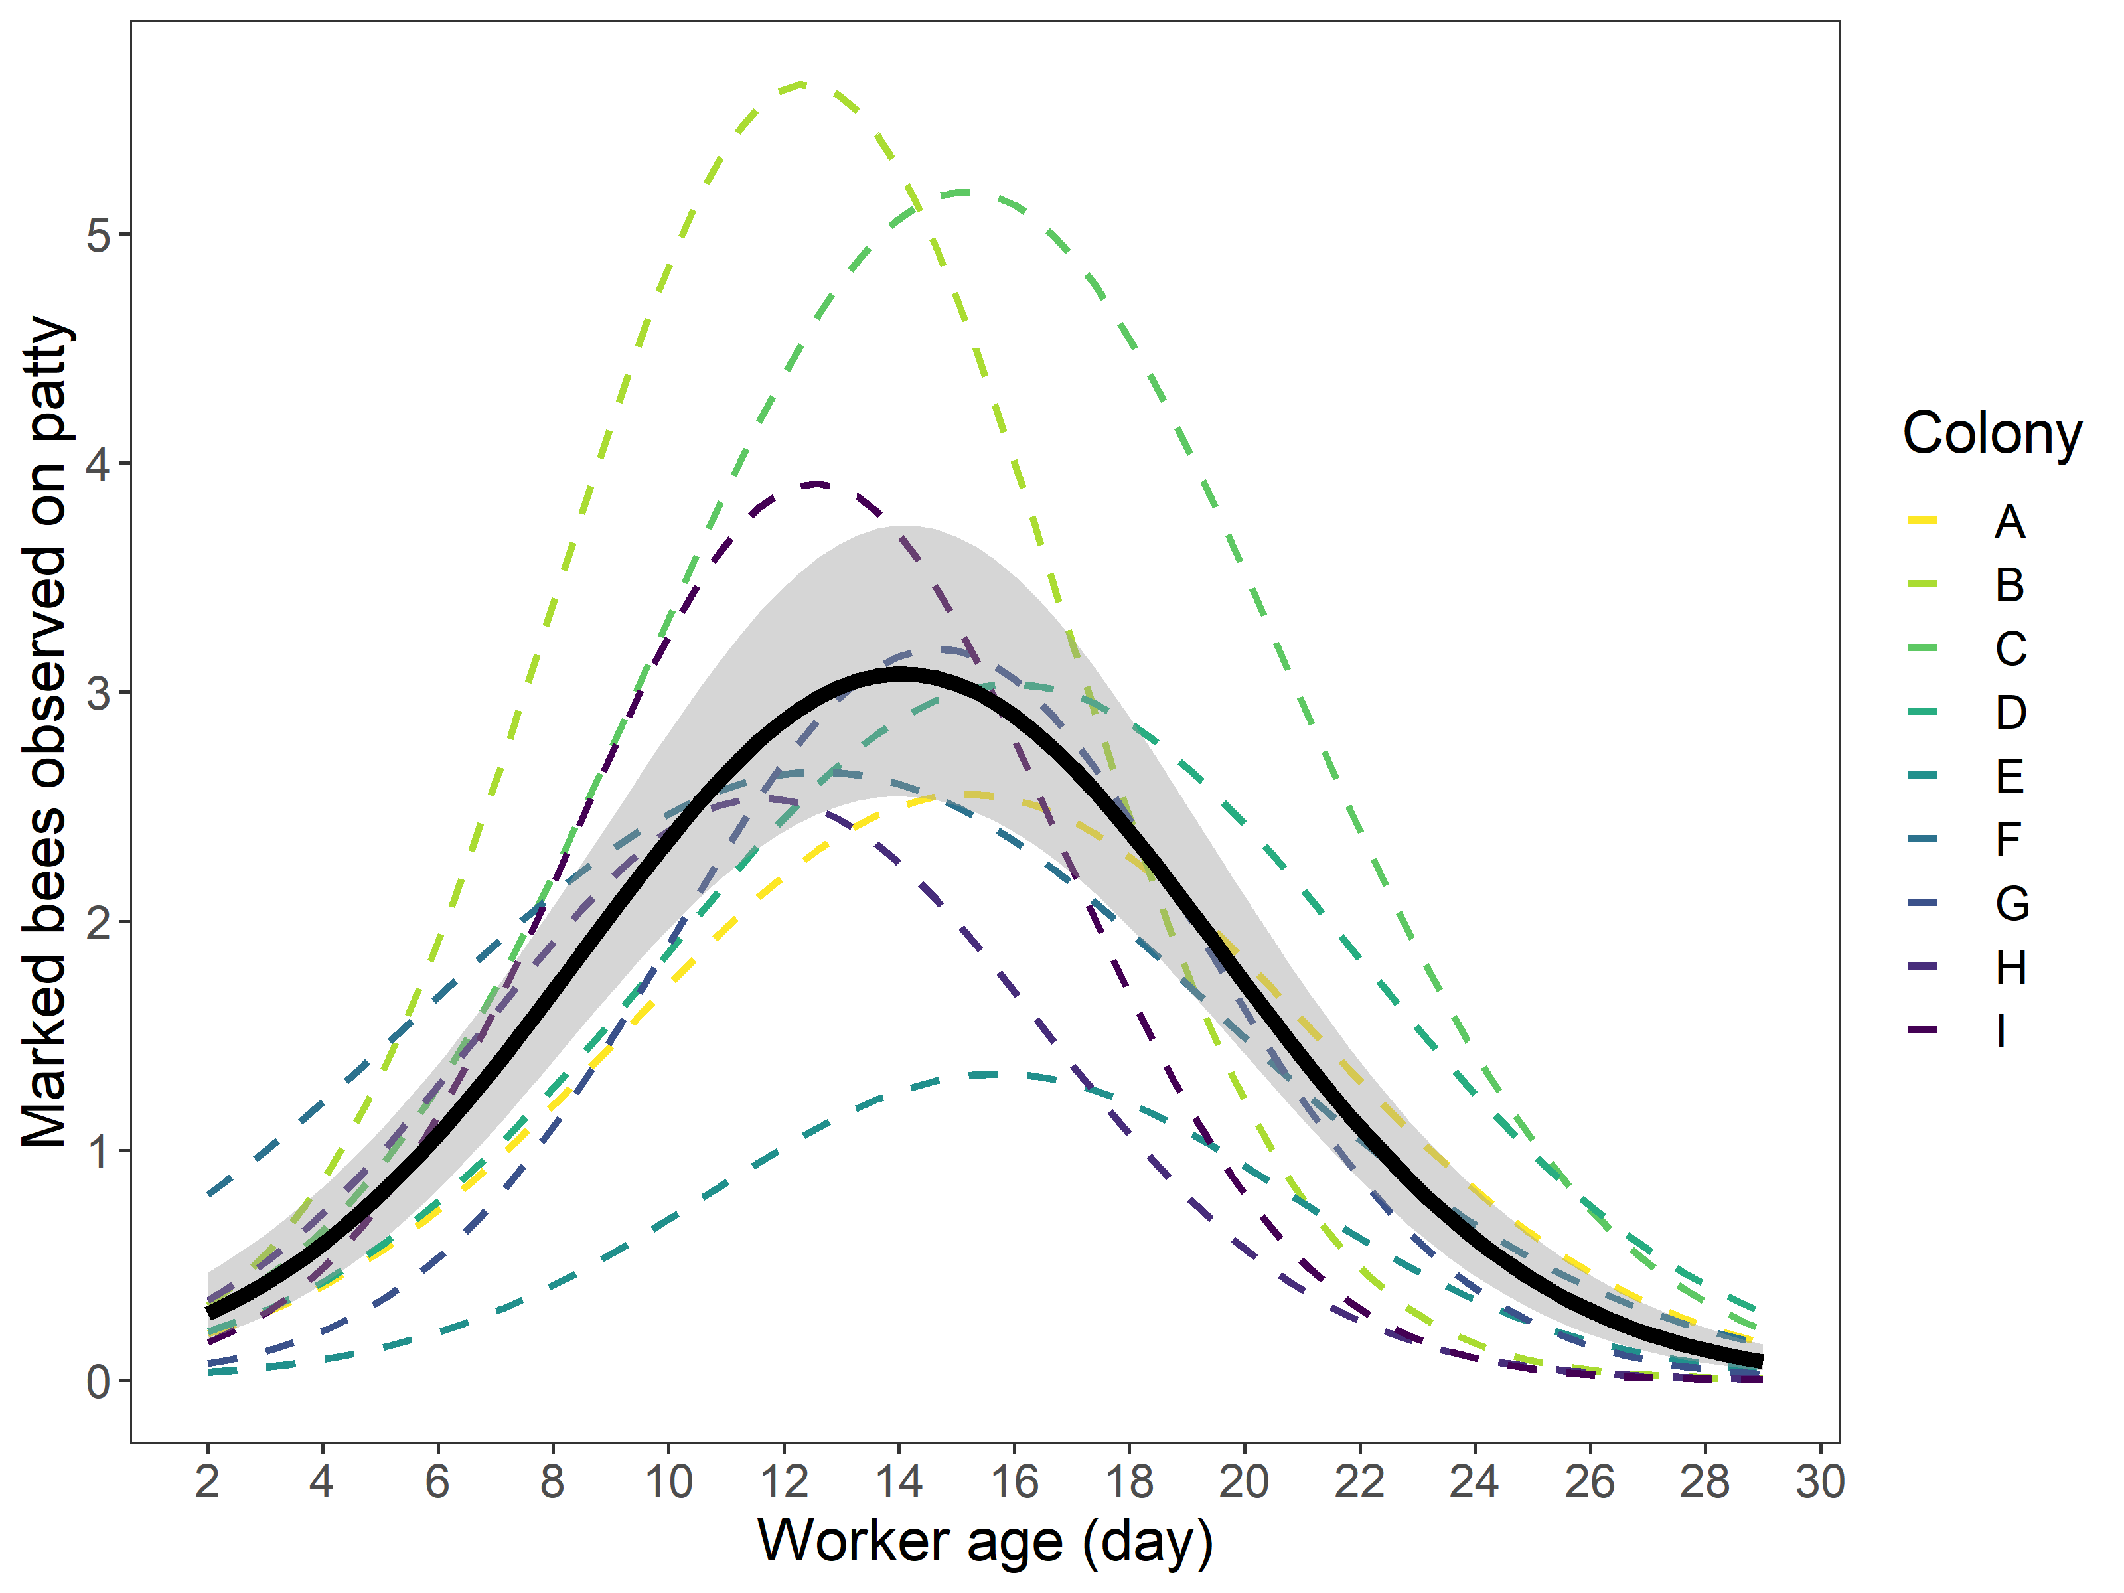
Figure 2. Number of bees observed on pollen substitute patty as worker age increases. The continuous black line with gray shading represents the estimated curve and 95% confidence interval from a generalized linear model with a negative binomial distribution of all colonies. Estimated curves for each of the six colonies are represented by the multicolor dashed lines. On average, dye presence peaks at 19 days of age. The proportion and timing of dye presence varies by colony.

Table 3. Estimated Marginal Means (EMMs) and 95% confidence intervals back-transformed to the proportion of dye presence in the abdomens of adult worker honey bees at various ages.
Age of workers (day) | Proportion of workers with dye (EMM) | 95% CI
2 | 0.090 | 0.052-0.151
4 | 0.156 | 0.104-0.229
6 | 0.242 | 0.176-0.324
8 | 0.339 | 0.260-0.428
10 | 0.433 | 0.343-0.526
12 | 0.512 | 0.416-0.607
14 | 0.573 | 0.475-0.666
16 | 0.614 | 0.517-0.702
18 | 0.636 | 0.542-0.720
20 | 0.640 | 0.549-0.722
22 | 0.626 | 0.534-0.710
24 | 0.595 | 0.494-0.688
26 | 0.543 | 0.425-0.657
28 | 0.472 | 0.331-0.618

Table 3. Estimated Marginal Means (EMMs) and 95% confidence intervals back-transformed to the number of marked bees observed on pollen supplement patties at various ages.
Age of workers (day) | Number of bees observed on patty | 95% CI
2 | 0.082 | 0.042 - 0.161
4 | 0.189 | 0.113 - 0.315
6 | 0.391 | 0.261 - 0.586
8 | 0.732 | 0.517 - 1.036
10 | 1.237 | 0.890 - 1.721
12 | 1.889 | 1.357 - 2.629
14 | 2.605 | 1.868 - 3.634
16 | 3.246 | 2.335 - 4.513
18 | 3.653 | 2.639 - 5.056
20 | 3.713 | 2.659 - 5.185
22 | 3.409 | 2.336 - 4.975
24 | 2.827 | 1.763 - 4.535
26 | 2.118 | 1.140 - 3.936
28 | 1.433 | 0.635 – 3.234

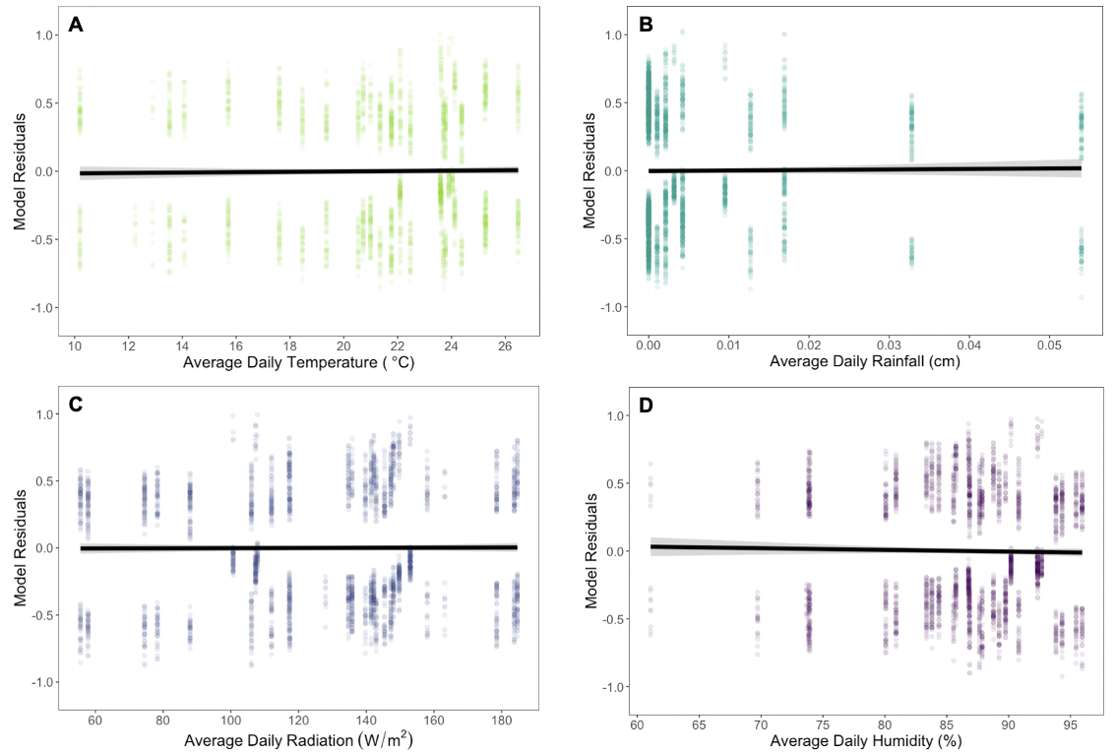
Figure 3. Evaluating the impact of average daily (A) temperature, (B) rainfall, (C) radiation, and (D) humidity on dye presence from pollen substitute patty consumption throughout worker age. Each environmental variable was plotted against the residuals from a generalized linear mixed effects model with a binomial distribution, age as linear and quadratic fixed effect predictor variables, a hive random effect with a first-order autoregressive (AR1) correlation structure, and every other weather variable other than the plotted. The continuous black lines with gray shading represent the relationship between the environmental variables and the age model. The lines and 95% confidence intervals were calculated from a generalized linear model. The slopes are nearly zero for all four environmental variables, indicating they have minimal to no effect on dye presence across worker age.

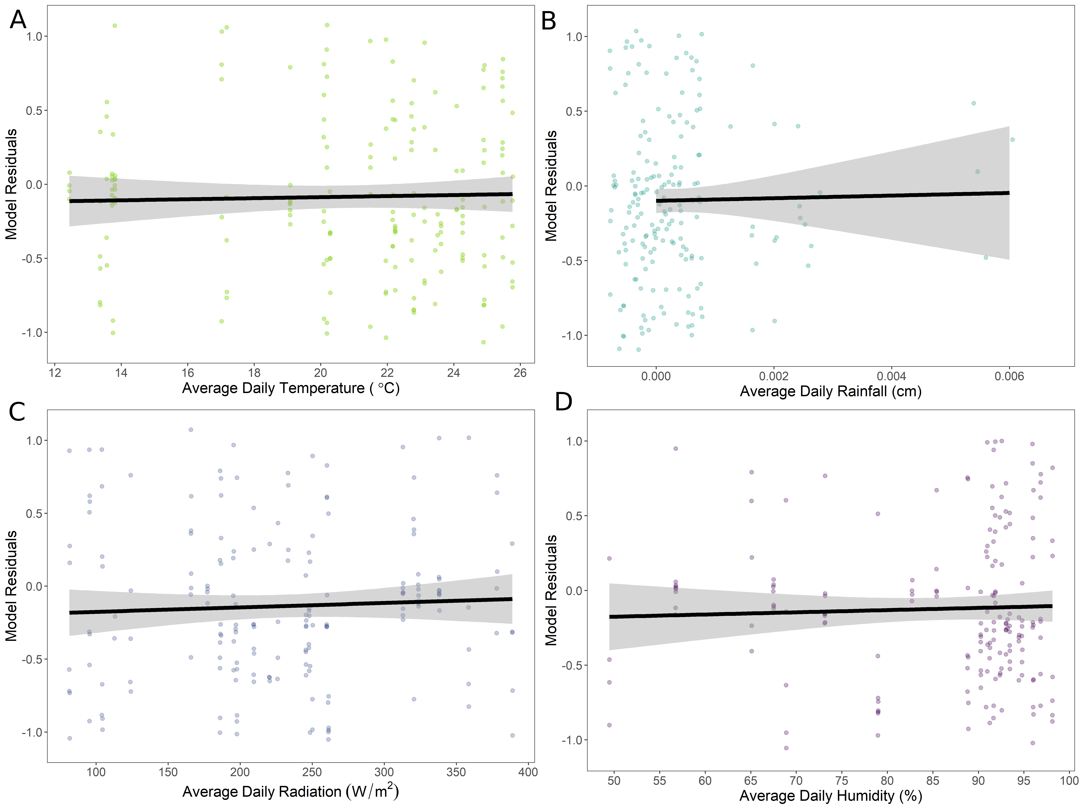
Figure 4. Evaluating the impact of average daily (A) temperature, (B) rainfall, (C) radiation, and (D) humidity on number of marked bees observed on pollen substitute patty throughout worker age. Each environmental variable was plotted against the residuals from a generalized linear mixed effects model with a negative binomial distribution, age as linear and quadratic fixed effect predictor variables, an offset variable (log total number of bees), a hive random effect with a first-order autoregressive (AR1) correlation structure, and every other weather variable besides the variable plotted. The continuous black lines with gray shading represent the relationship between the environmental variables and the age model. The lines and 95% confidence intervals were calculated from a generalized linear model.

